RF2-RFL:Visibility, Distance*AbsoluteHumidity,Distance*RainIntensity,FSO_pred*Temperature

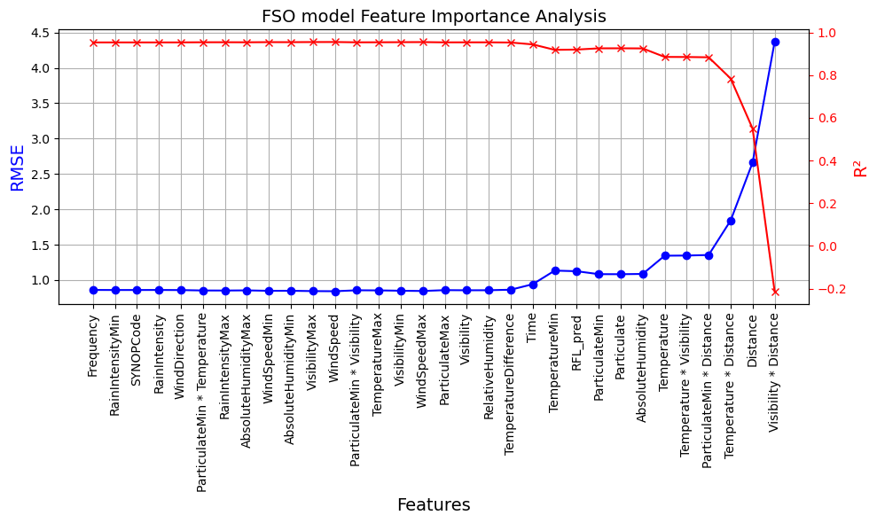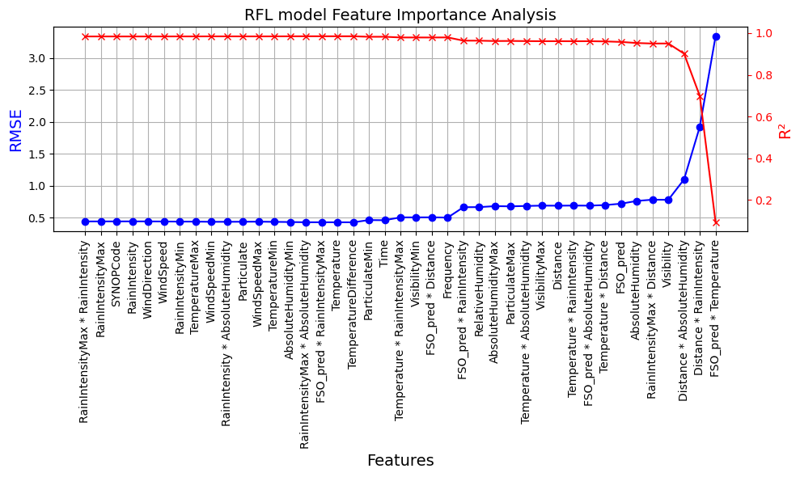RF2-FSO:ParticulateMin*Distance,Temperature*Distance,Distance,Visibility*Distance